Explainable Artificial Intelligence (XAI)
Explainable artificial intelligence (XAI) refers to a collection of procedures and techniques that enable machine learning algorithms to produce output and results that are understandable and reliable for human users.
- Explainable AI is a key component of the fairness, accountability, and transparency (FAT) machine learning paradigm and is frequently discussed in connection with deep learning.
- Organizations looking to establish trust when deploying AI can benefit from XAI. XAI can assist them in comprehending the behavior of an AI model and identifying possible problems like AI.
- Overall, the value of explainable AI lies in its ability to provide transparent and interpretable machine-learning models that can be understood and trusted by humans. This value can be realized in different domains and applications and can provide a range of benefits and advantages.
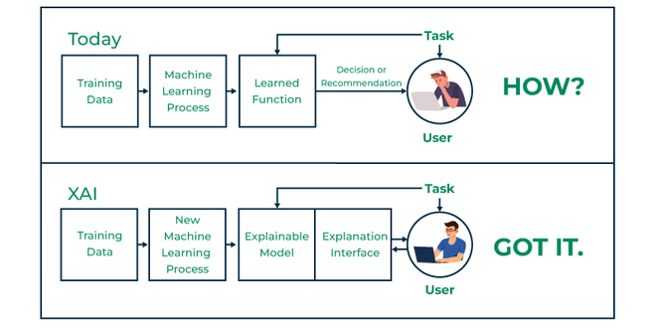

Explainable Artificial Intelligence Concept

Benefits of explainable AI
The value of explainable AI lies in its ability to provide transparent and interpretable machine-learning models that can be understood and trusted by humans. This value can be realized in different domains and applications and can provide a range of benefits and advantages. Some of the key values of explainable AI include:
1. Improved decision-making:- Explainable AI can provide valuable insights and information that can be used to support and improve decision-making. For example, explainable AI can provide insights into the factors that are most relevant and influential in the model's predictions.
2. Increased trust and acceptance:- Explainable AI can help to build trust and acceptance of machine learning models, and can overcome the challenges and limitations of traditional machine learning models, which are often opaque and inscrutable.
3. Reduced risks and liabilities:- Explainable AI can help to reduce the risks and liabilities of machine learning models, and can provide a framework for addressing the regulatory and ethical considerations of this technology. This reduced risk and liability can help to mitigate the potential impacts and consequences of machine learning, and can provide valuable insights and benefits in different domains and applications.

How does Explainable AI work?
The architecture of explainable AI depends on the specific approaches and methods that are used to provide transparency and interpretability in machine learning models. However, in general, explainable AI architecture can be thought of as a combination of three key components:
- Machine learning model:- The machine learning model is the core component of explainable AI, and represents the underlying algorithms and techniques that are used to make predictions and inferences from data. This component can be based on a wide range of machine learning techniques, such as supervised, unsupervised, or reinforcement learning, and can be used in a range of applications, such as medical imaging, natural language processing, and computer vision.
- Explanation algorithm:- The explanation algorithm is the component of explainable AI that is used to provide insights and information about the factors that are most relevant and influential in the model's predictions. This component can be based on different explainable AI approaches, such as feature importance, attribution, and visualization, and can provide valuable insights into the workings of the machine learning model.
- Interface:- The interface is the component of explainable AI that is used to present the insights and information generated by the explanation algorithm to humans. This component can be based on a wide range of technologies and platforms, such as web applications, mobile apps, and visualizations, and can provide a user-friendly and intuitive way to access and interact with the insights and information generated by the explainable AI system.

Explainable AI principles
Explainable AI (XAI) principles are a set of guidelines and recommendations that can be used to develop and deploy transparent and interpretable machine learning models.
- Transparency:- XAI should be transparent and should provide insights and information about the factors that are most relevant and influential in the model's predictions. This transparency can help to build trust and acceptance of XAI and can provide valuable insights and benefits in different domains and applications.
- Interpretability:- XAI should be interpretable and should provide a clear and intuitive way to understand and use the insights and information generated by XAI. This interpretability can help to overcome the challenges and limitations of traditional machine learning models, which are often opaque and inscrutable, and can provide valuable insights and benefits in different domains and applications.
- Accountability:- XAI should be accountable and should provide a framework for addressing the regulatory and ethical considerations of machine learning. This accountability can help to ensure that XAI is used in a responsible and accountable manner, and can provide valuable insights and benefits in different domains and applications.

Explainable AI approaches
There are several different explainable AI approaches that aim to provide more transparent and interpretable machine learning models. Some of the most common explainable AI approaches include:
- Feature importance:- This approach is based on the idea that each input feature or variable contributes to the model's predictions in a different way, and that some features are more important than others. Feature importance techniques aim to identify and rank the importance of each feature, and can provide insights into the factors that are most relevant and influential in the model's predictions.
- Attribution:- This approach is based on the idea that each input feature or variable contributes to the model's predictions in a different way, and that these contributions can be measured and quantified. Attribution techniques aim to attribute the model's predictions to each input feature and can provide insights into the factors that are most relevant and influential in the model's predictions.
- Visualization:- This approach is based on the idea that graphical and visual representations can be more effective and intuitive than numerical and textual representations in explaining and interpreting machine learning models. Visualization techniques aim to represent the model's structure, parameters, and predictions in a visual and interactive way and can provide insights into the model's behavior and performance.

Explainable AI (XAI) Techniques
To implement explainable AI (XAI) in python, you can use one of the following approaches:
- LIME (Local Interpretable Model-agnostic Explanations):- LIME is a popular XAI approach that uses a local approximation of the model to provide interpretable and explainable insights into the factors that are most relevant and influential in the model's predictions. To implement LIME in python, you can use the lime package, which provides a range of tools and functions for generating and interpreting LIME explanations.
- SHAP (SHapley Additive exPlanations):- SHAP is an XAI approach that uses the Shapley value from game theory to provide interpretable and explainable insights into the factors that are most relevant and influential in the model's predictions. To implement SHAP in python, you can use the shap package, which provides a range of tools and functions for generating and interpreting SHAP explanations.
- ELI5 (Explain Like I'm 5):- ELI5 is an XAI approach that provides interpretable and explainable insights into the factors that are most relevant and influential in the model's predictions, using a simple and intuitive language that can be understood by non-experts. To implement ELI5 in python, you can use the eli5 package, which provides a range of tools and functions for generating and interpreting ELI5 explanations.
- Overall, there are several approaches that you can use to implement XAI in python, including LIME, SHAP, and ELI5. These approaches provide different levels of interpretability and explainability and can be used in a range of applications and domains.

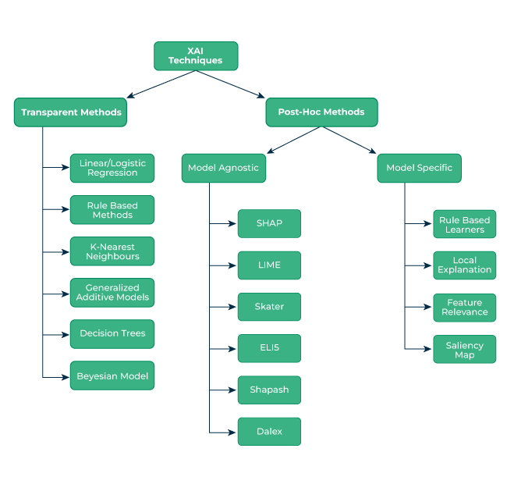
Explainable AI Techniques

Explainable AI (XAI) using the LIME approach in Python
To implement explainable AI (XAI) using the LIME approach in python, you can follow these steps:
- Install the lime package by running the following command
!pip install lime
- Import the required modules, such as lime, NumPy, and sklearn, by running the following code
import lime
import numpy as np
import sklearn.ensemble
import lime.lime_tabular
import IPython
from sklearn import datasets

- Load the data and train the machine learning model

# load the data and train the model
X, y = sklearn.datasets.load_iris(return_X_y=True)
model = sklearn.ensemble.RandomForestClassifier()
model.fit(X, y)

In this step, the code uses the load_iris function from sklearn.datasets module to load the iris dataset, which is a well-known dataset that contains measurements of the sepal and petal lengths and widths of iris flowers, along with the corresponding species of each flower. The code then trains a random forest classifier on the iris dataset using the RandomForestClassifier class from the sklearn.ensemble module.

- Create a LIME explainer instance

# create a LIME explainer instance
explainer = lime.lime_tabular.LimeTabularExplainer(
X,
feature_names=['sepal length', 'sepal width', 'petal length', 'petal width'],
class_names=['setosa', 'versicolor', 'virginica']
)

In this step, the code creates a LIME explainer instance using the LimeTabularExplainer class from the lime.lime_tabular module. The explainer is initialized with the feature names and class names of the iris dataset so that the LIME explanation can use these names to interpret the factors that contributed to the predicted class of the instance being explained.
- Generate the LIME explanation

# generate the LIME explanation
exp = explainer.explain_instance(X[0], model.predict_proba, num_features=4)

In this step, the code uses the explain_instance method of the explainer instance to generate a LIME explanation for the first instance in the iris dataset. The explain_instance method takes the instance to be explained, the prediction function of the machine learning model, and the number of features to be included in the explanation as input. The method returns an Explanation object that contains the generated LIME explanation
- Saving the generated lime explanation output in an HTML file named op.html
file =open('op.html','w', encoding="utf-8")
print(file.write(exp.as_html()))

Output :

op.html is saved in a local folder.
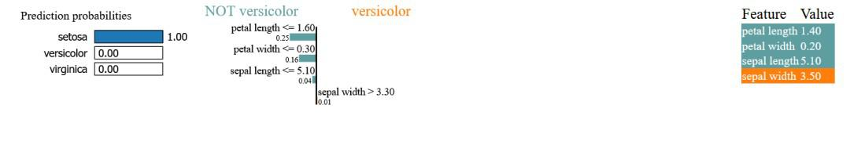

When you execute this code you will get a file named op.html as output. The HTML file that you got as output is the LIME explanation for the first instance in the iris dataset. The LIME explanation is a visual representation of the factors that contributed to the predicted class of the instance being explained. In the case of the iris dataset, the LIME explanation shows the contribution of each of the features (sepal length, sepal width, petal length, and petal width) to the predicted class (setosa, Versicolor, or Virginia) of the instance.

Current Limitations of XAI
There are several current limitations of explainable AI (XAI) that are important to consider. Some of the key limitations of XAI include:
- Computational complexity:- Many XAI approaches and methods are computationally complex, and can require significant resources and processing power to generate and interpret the insights and information that they provide. This computational complexity can be a challenge for real-time and large-scale applications and can limit the use and deployment of XAI in these contexts.
- Limited scope and domain-specificity:- Many XAI approaches and methods are limited in scope and domain-specificity, and may not be applicable or relevant to all machine learning models and applications. This limited scope and domain-specificity can be a challenge for XAI and can limit the use and deployment of this technology in different domains and applications.
- Lack of standardization and interoperability:- There is currently a lack of standardization and interoperability in the XAI field, and different XAI approaches and methods may use different metrics, algorithms, and frameworks, which can make it difficult to compare and evaluate these approaches and can limit the use and deployment of XAI in different domains and applications.
Overall, there are several current limitations of XAI that are important to consider, including computational complexity, limited scope and domain-specificity, and a lack of standardization and interoperability. These limitations can be challenging for XAI and can limit the use and deployment of this technology in different domains and applications.

Explainable AI Case studies
There are many examples and case studies of explainable AI in action, and these examples can provide valuable insights into the potential benefits and challenges of this approach. Some examples of explainable AI in different domains and applications include:
- Medical imaging:- In the medical imaging domain, explainable AI techniques can be used to provide insights into the factors that are most relevant and influential in the diagnosis of diseases and conditions. For example, explainable AI techniques can be used to identify and visualize the features that are most important in the diagnosis of cancer and can provide insights into the factors that are most predictive of a positive or negative outcome.
- Natural language processing:- In the natural language processing domain, explainable AI techniques can be used to provide insights into the factors that are most relevant and influential in the interpretation and analysis of the text. For example, explainable AI techniques can be used to identify and visualize the words and phrases that are most important in the classification of sentiment and can provide insights into the factors that are most predictive of positive or negative sentiment.
- Computer vision:- In the computer vision domain, explainable AI techniques can be used to provide insights into the factors that are most relevant and influential in the recognition and classification of images. For example, explainable AI techniques can be used to identify and visualize the regions of an image that are most important in the classification of objects and can provide insights into the factors that are most predictive of a specific object class.
Overall, these examples and case studies demonstrate the potential benefits and challenges of explainable AI and can provide valuable insights into the potential applications and implications of this approach.

Which companies are using Explainable AI?
There are many companies that are using explainable AI to develop and deploy transparent and interpretable machine learning models. Some examples of companies that are using explainable AI include:
- Google - Google is using explainable AI in a range of applications, such as medical imaging, natural language processing, and computer vision. For example, Google's DALL-E machine learning model uses explainable AI to generate images from text descriptions and provides insights into the factors that are most relevant and influential in the model's predictions.
- Apple - Apple is using explainable AI in a range of applications, such as medical imaging, natural language processing, and computer vision. For example, Apple's Core ML machine learning framework uses explainable AI to provide insights into the factors that are most relevant and influential in the model's predictions and can help to identify and mitigate potential biases and discrimination in the model's behavior and performance.
- Microsoft - Microsoft is using explainable AI in a range of applications, such as medical imaging, natural language processing, and computer vision. For example, Microsoft's Explainable Boosting Machine learning algorithm uses explainable AI to provide insights into the factors that are most relevant and influential in the model's predictions and can help to identify and mitigate potential biases and discrimination in the model's behavior and performance.
Overall, these companies are using explainable AI to develop and deploy transparent and interpretable machine learning models, and are using this technology to provide valuable insights and benefits in different domains and applications.

Explainable AI Future developments and trends
There are many future developments and trends in the field of explainable AI, and these developments are likely to have significant implications and applications in different domains and applications. Some of the most significant future developments and trends in explainable AI include:
- New methods and approaches - In the future, new methods and approaches are likely to emerge that can provide more transparent and interpretable machine learning models. These methods and approaches could be based on different principles and perspectives and could provide more comprehensive and nuanced insights into the workings of machine learning models.
- Increased demand and adoption - In the future, there is likely to be increased demand and adoption of explainable AI, as more organizations and individuals recognize the benefits and advantages of transparent and interpretable machine learning models. This increased demand and adoption could drive the development and deployment of new explainable AI methods and approaches and could lead to more widespread and impactful applications of this technology.
- Regulatory and ethical considerations - In the future, there is likely to be greater focus on the regulatory and ethical considerations of explainable AI, as more organizations and individuals recognize the potential implications and impacts of this technology. This could lead to the development of new standards, guidelines, and frameworks for explainable AI, and could provide a framework for responsible and ethical use of this technology.
Origin of Explainable AI
One of the key early developments in explainable AI was the work of Judea Pearl, who introduced the concept of causality in machine learning, and proposed a framework for understanding and explaining the factors that are most relevant and influential in the model's predictions. This work laid the foundation for many of the explainable AI approaches and methods that are used today and provided a framework for transparent and interpretable machine learning.
Another important development in explainable AI was the work of LIME (Local Interpretable Model-agnostic Explanations), which introduced a method for providing interpretable and explainable machine learning models. This method uses a local approximation of the model to provide insights into the factors that are most relevant and influential in the model's predictions and has been widely used in a range of applications and domains.

